**Step 1:**

**Open SFDI_ROI_v2.m (*this is the main code*)**

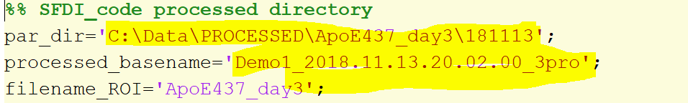

Put in the processed directory and filename of the results processed by the SFDI code.

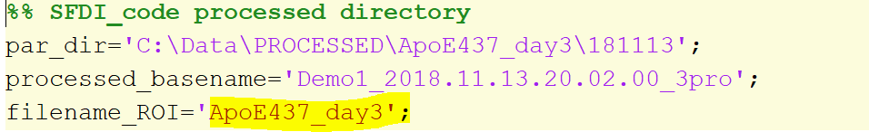

Add a desired filename (*this is where the chromophore results within test and control ROI will get saved*).

**Step 2:**

Run the code.

2 figures will pop up:

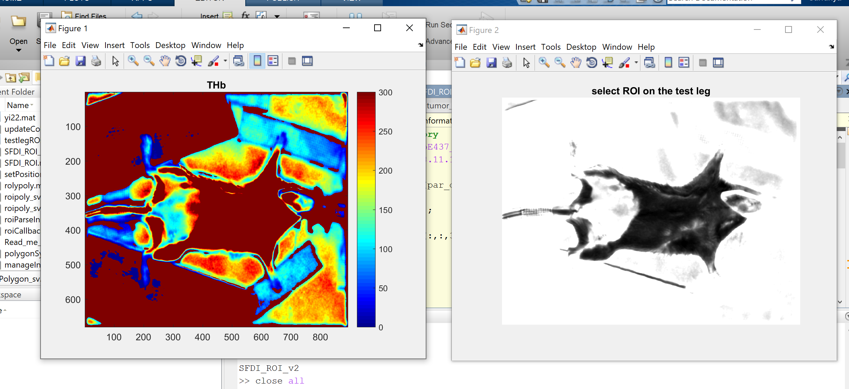

Figure 1 is the total hemoglobin map and figure 2 is a raw file where you will select ROI on the test leg.

**Step 3 a:**

Select ROI on the test leg

Pick a few points to complete a polygon that covers the desired ROI (*Use single clicks when you do this*)

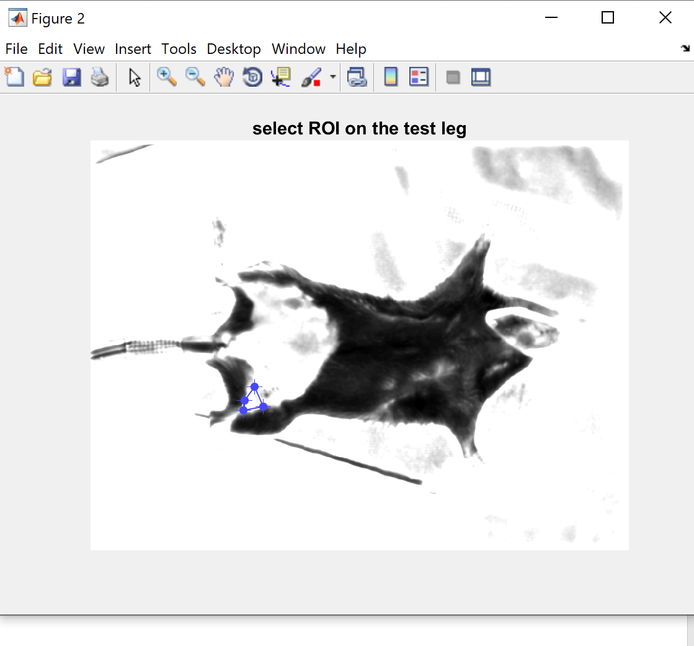

**Step 3 b:**

You can move the vertices around until you are satisfied with the polygon shape. An example has been shown below:

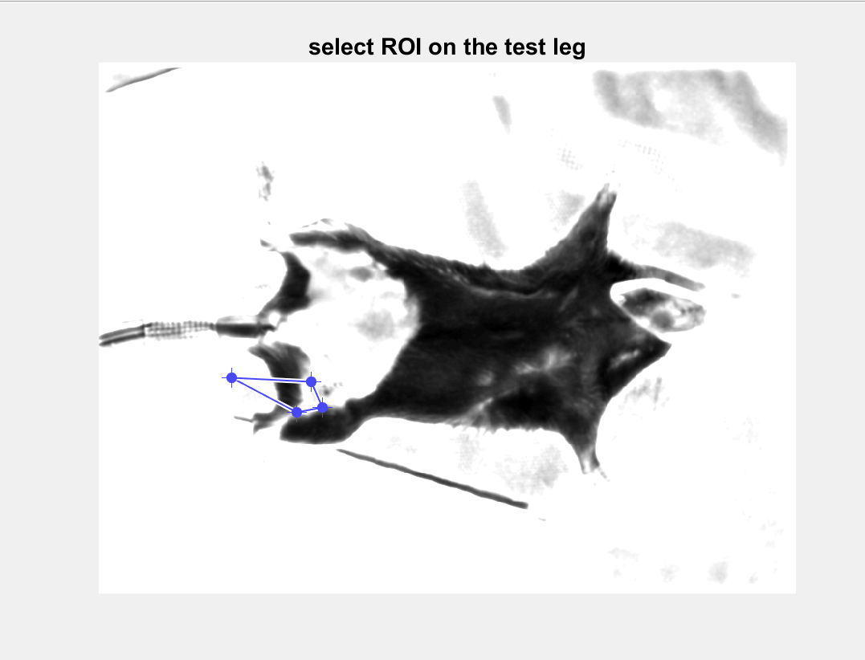

**Step 3 c.**

If you hover the mouse over the ROI you will find that the pointer changes to 

You can then move around your ROI on the test leg.

An example is shown below:

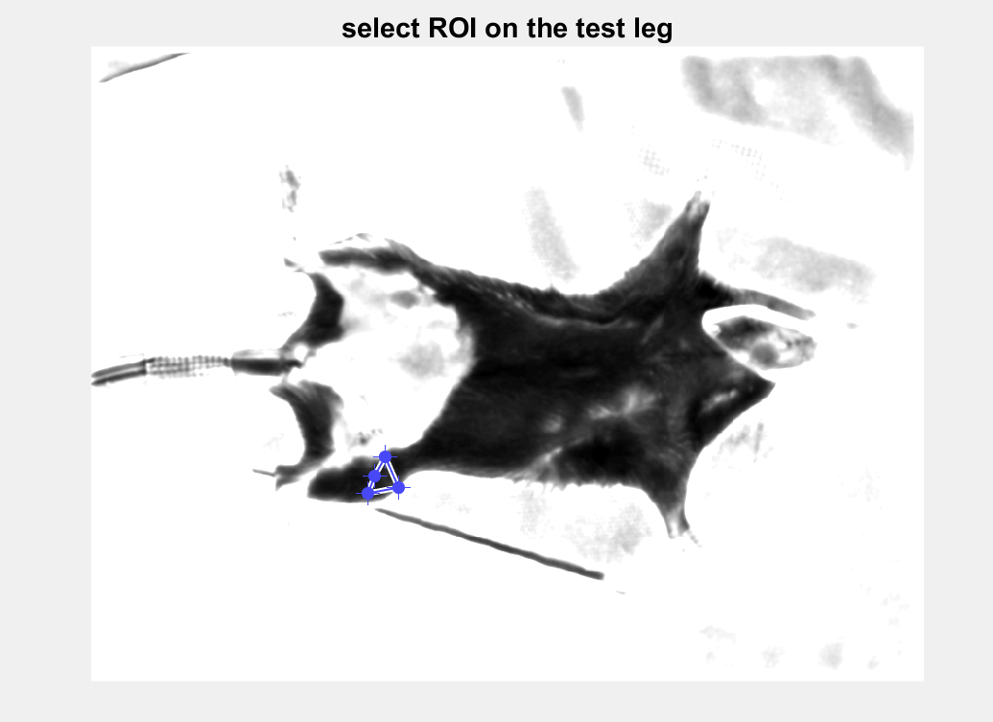

**Step 3 d.**

Once you are happy with test leg ROI, right click to open your options menu:

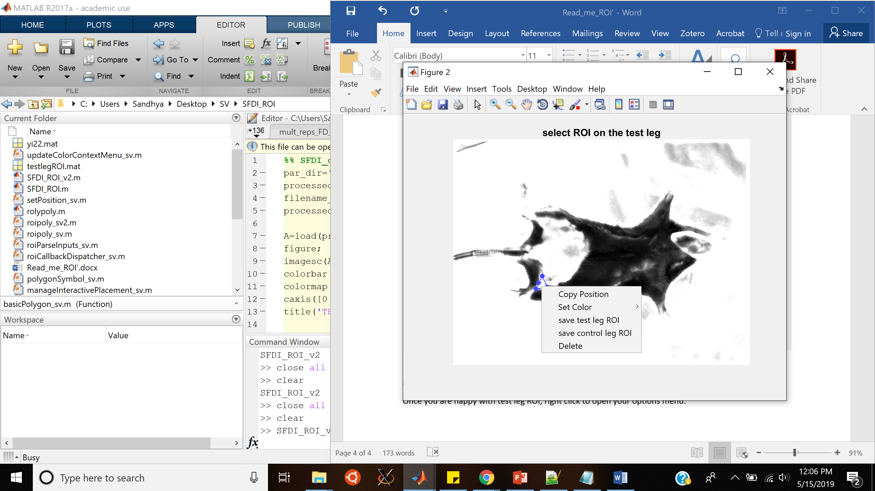

Click on save test leg ROI.

**Step 3 e.**

Double click on the ROI

**Step 4 a.**

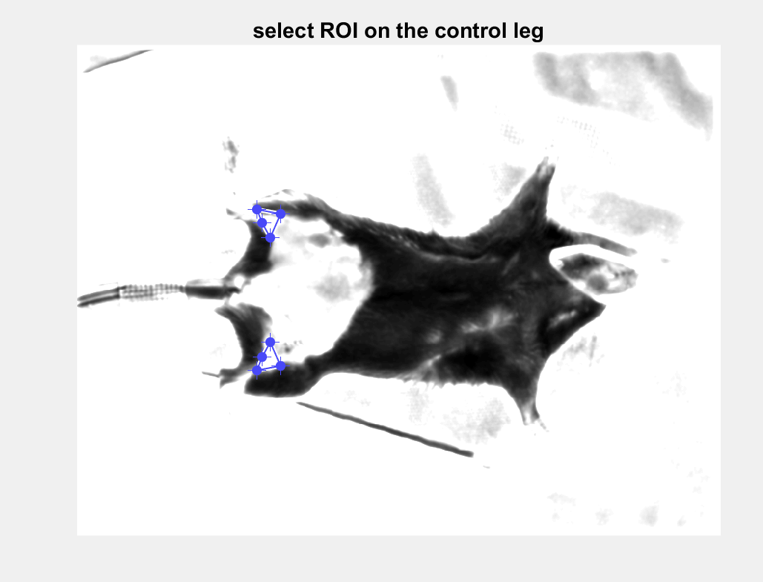

The ROI on the control leg automatically pops up.

**Step 4 b.**

You can adjust the location of the control leg ROI. Example given below

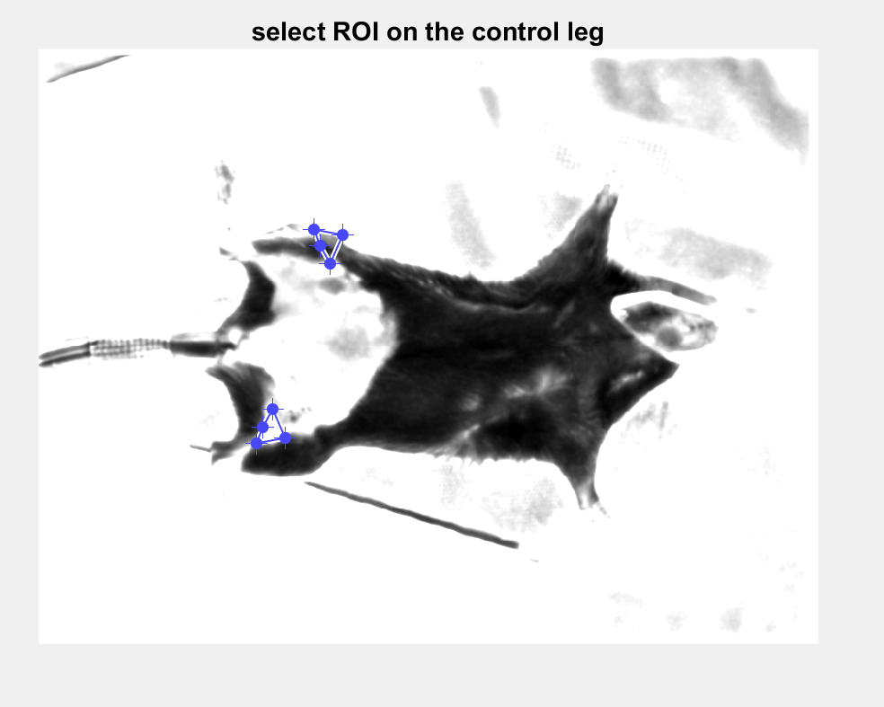

**Step 4 c.**

Once you are happy with the location of the control leg ROI, right click to open the options menu

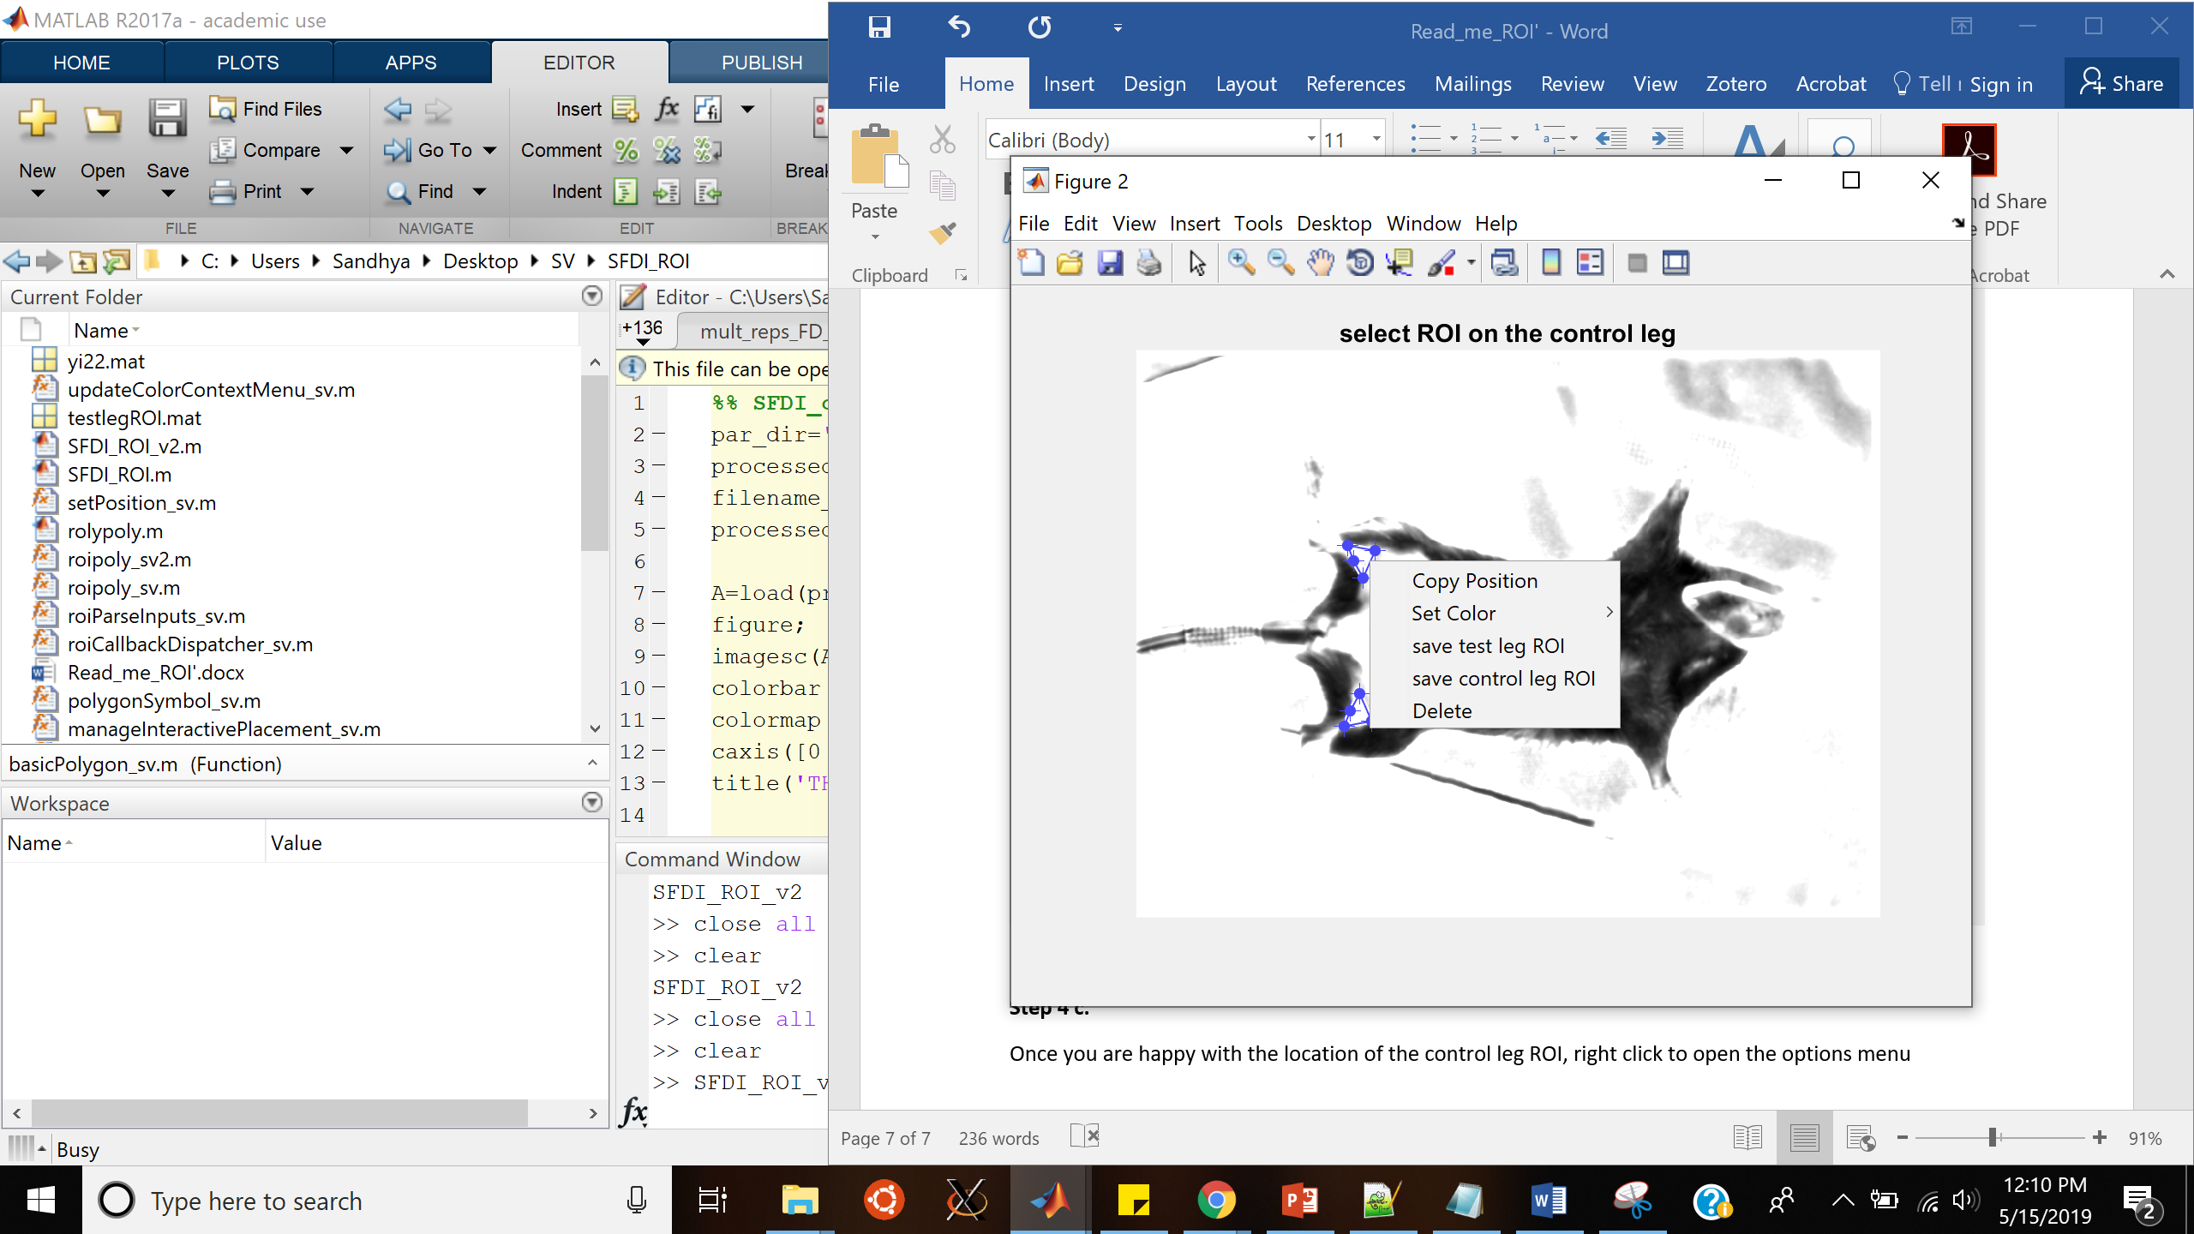

**Step 4 d.**

Click on save control leg ROI

**Step 4 e.**

Double click on the ROI.

**Step 5.**

The selected ROIs will pop up on both figures

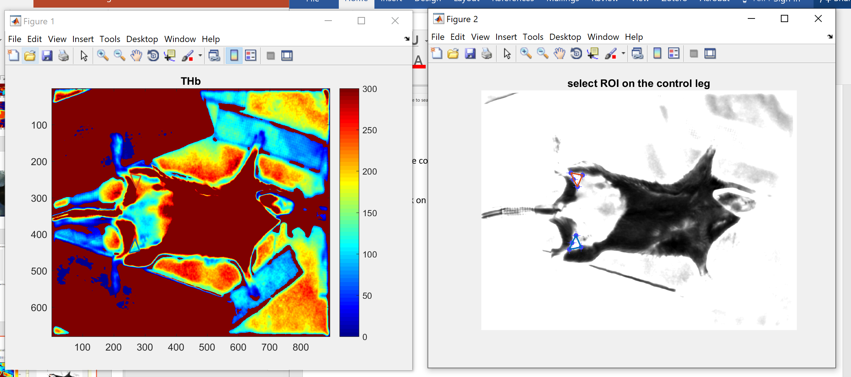

**Step 6:**

You will find a text file in the current matlab directory which has the ROI chromophore values saved.

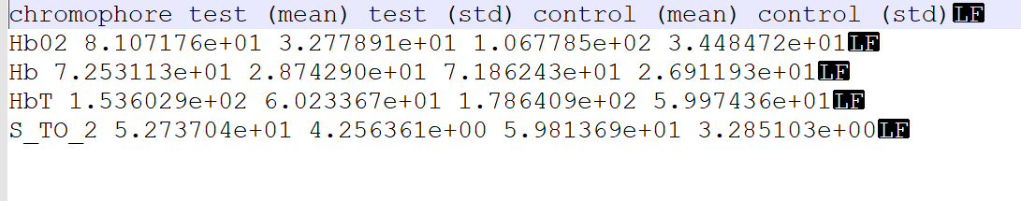

The code will also populate a text file containing the absorption and reduced scattering over the regions selected.

